Batch: A-3 Roll No.: 16010122104
Experiment No. 6
Grade: AA / AB / BB / BC / CC / CD /DD

Title: VM creation on Microsoft Azure

Objective:

Expected Outcome of Experiment:

CO | Outcome
CO4 | Build cloud services and applications

Books/ Journals/ Websites referred:

https://www.cloudskillsboost.google/

Abstract:-
Virtual Machine (VM) creation on Microsoft Azure leverages advanced virtualization technologies to provide scalable and efficient cloud-based computing environments. Using Infrastructure as a Service (IaaS), users can deploy customizable virtual hardware tailored to their specific needs. The process involves provisioning resources such as CPU, memory, storage, and network configurations through declarative descriptions or templates. Azure supports live migration techniques for load balancing and maintenance while enabling roles like Web Role, Worker Role, and Virtual Machine Role to facilitate distributed application development. Resource pooling ensures optimal utilization of physical infrastructure while maintaining high availability through elastic scaling and disaster recovery mechanisms. These capabilities make Azure an ideal platform for deploying robust cloud applications across public, private, or hybrid cloud models
Related Theory: -
Virtual Machine (VM) creation on Microsoft Azure involves provisioning virtualized computing resources from a cloud infrastructure. The theory underlying this process is rooted in virtualization, cloud computing models, and resource management. Key concepts include:

Virtualization:

Virtualization enables the abstraction of physical hardware into virtual resources, allowing multiple VMs to run on a single physical machine. This is achieved using hypervisors like Microsoft's Hyper-V, which manage hardware-level virtualization.

Virtualization layers include instruction set architecture (ISA), hardware, operating system, library support, and application levels. Each level provides specific capabilities for VM creation and management.

Cloud Service Models:

Azure supports Infrastructure as a Service (IaaS), which provides customizable virtual hardware for deploying computing systems. Users can select configurations such as CPU, memory, storage, and network settings.

Azure also offers Platform as a Service (PaaS) for application development and Software as a Service (SaaS) for ready-to-use applications.

VM Provisioning:

VM provisioning involves selecting a server with an appropriate operating system, loading necessary software, configuring network settings (e.g., IP address), and associating storage resources.

Live migration techniques like "hot migration" are used for load balancing or recovery scenarios. Migration stages include reservation, iterative pre-copying of memory pages, stop-and-copy, commitment, and activation.

Azure-Specific Features:

Azure provides roles such as Web Role (hosting web applications), Worker Role (processing workloads), and Virtual Machine Role (offering a virtual environment).

It includes tools like Azure Tables for scalable data storage and Azure Queues for reliable message delivery between processes.

Resource Management:

VMs are managed through resource pooling and dynamic allocation to optimize utilization and scalability. Azure ensures high availability through mechanisms like elastic scaling and disaster recovery.
Implementation Details:
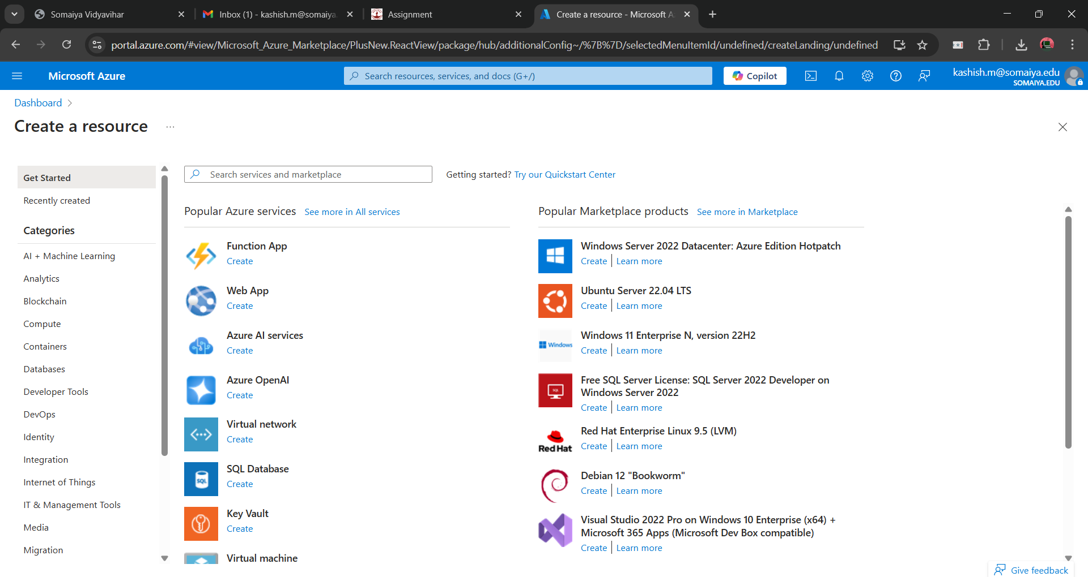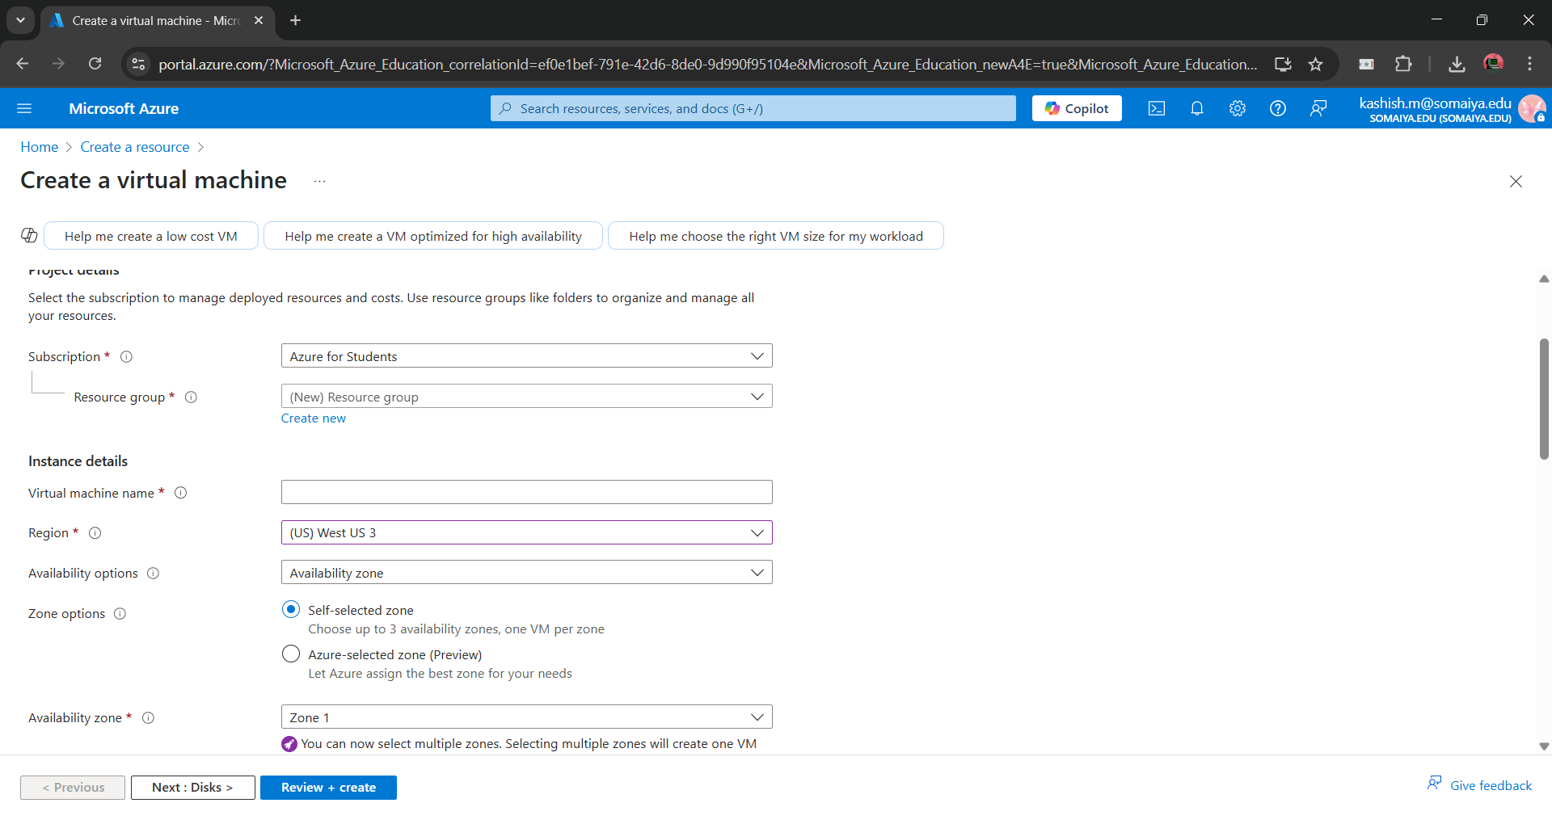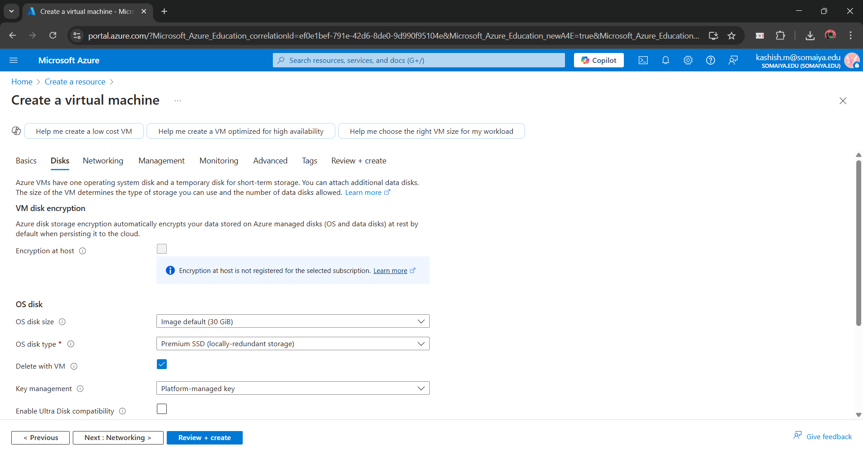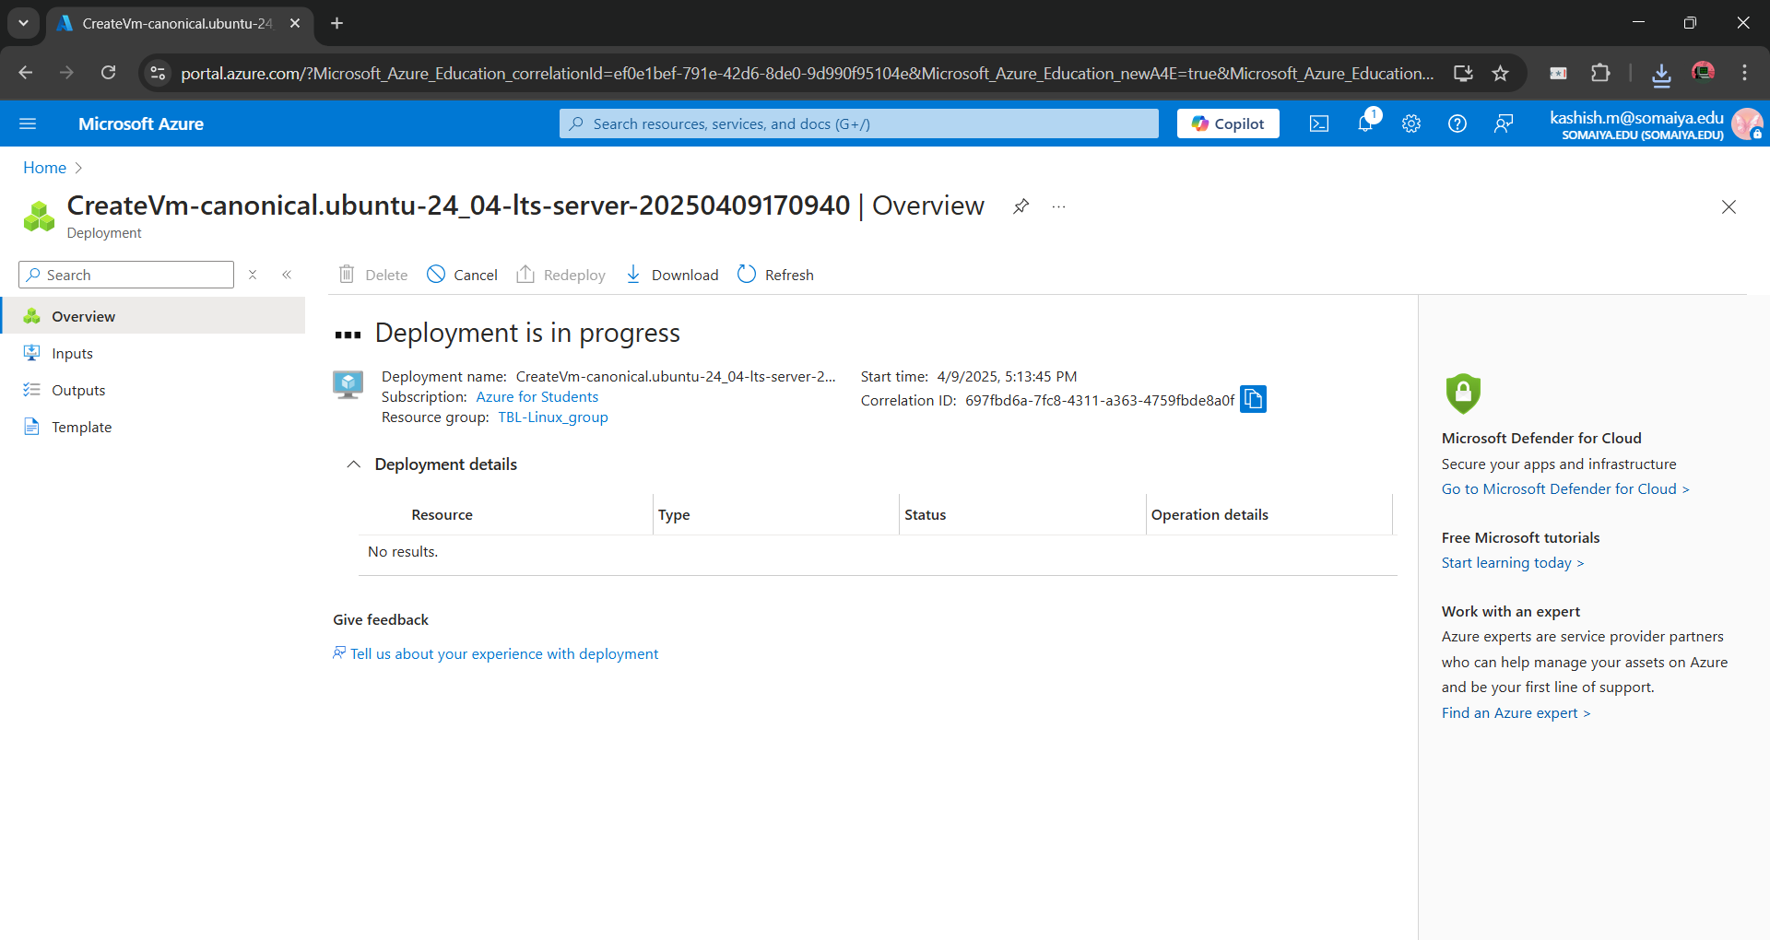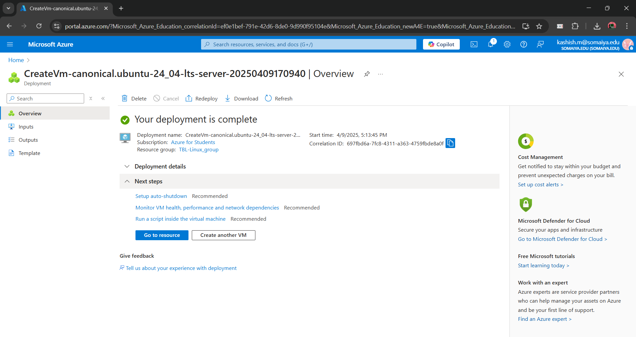
Conclusion:-
We created a Virtual Machine using Microsoft Azure.

